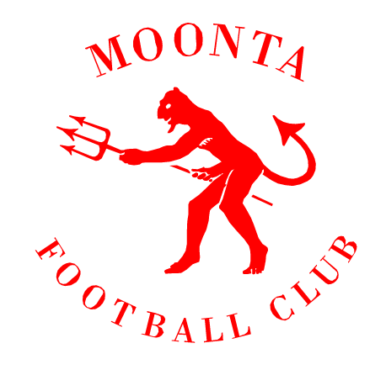

MORE SPONSORSHIP OPTIONS

As you can see with the Sponsorship Packages already presented, the club tries to cater for a wide variety of businesses and financial situations. The ability for all sponsors to make incremental payments this year, is an option which may assist some businesses with managing things better. Any Sponsorship at all is greatly appreciated.

There are other ways to assist in sponsoring the Club. If you can think of any alternative ways to sponsor and support our club that has not been mentioned, then please do not hesitate to contact one of our Committee Members to discuss things further. These will be taken back to the Committee for discussion.

Alternative examples such as extra signage around certain areas of our oval and facilities (eg. the scoreboard, ticket Box, coaches boxes…) could be something you would like to discuss; or sponsoring goal post padding with your business logo on them.

Please contact either Dave Love on m 0456214740 or Mark Durdin on
m 0416436872 with your ideas.

‘On The Dees in Twenty Three’

